Mobile Development
Lab 5
Touqeer ul Hussnain Raza
- NTU-CS-1128
BSSE 6

Links:

Question 1:
import 'package:flutter/material.dart';
import 'dart:math';

void main() {
runApp(MaterialApp(
home: BallPage(),

));
}

class BallPage extends StatelessWidget {
const BallPage({ Key? key }) : super(key: key);

@override
Widget build(BuildContext context) {

return Scaffold(
appBar: AppBar(title: Text("As me anything"),),
body: Container(
color: Colors.blue,
child: UpdateScreen(),

),

);

}
}

class UpdateScreen extends StatefulWidget {
const UpdateScreen({ Key? key }) : super(key: key);

@override
State<UpdateScreen> createState() => _UpdateScreenState();
}

class _UpdateScreenState extends State<UpdateScreen> {
@override
int number = 1;
Widget build(BuildContext context) {

return Center(

child: Container(
color: Colors.blue[900],
child: FlatButton(
child: Image.asset('assets/images/ball$number.png',height: double.infinity, width: double.infinity,),
onPressed: (){
print('I got clicked ');
print("random number : $number");
setState(() {
number = Random().nextInt(4)+1;
});
},
)

)
);
}
}

Solution
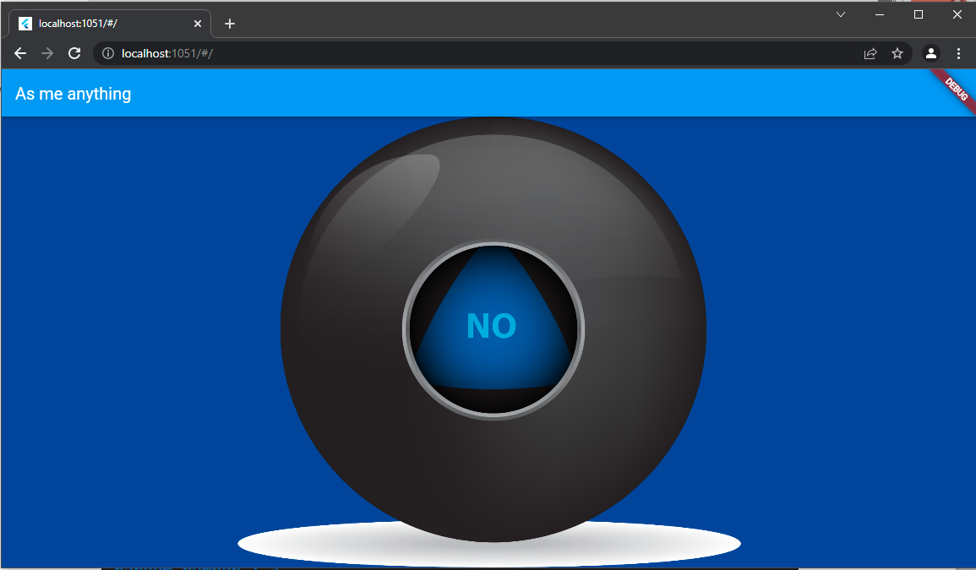

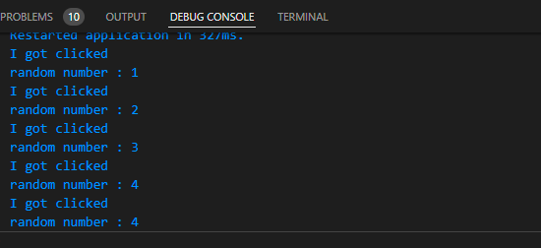

Question 2:
import 'package:flutter/material.dart';
import 'package:audioplayers/audioplayers.dart';
void main() {
runApp(const MyApp());
}

class MyApp extends StatefulWidget {
const MyApp({ Key? key }) : super(key: key);

@override
State<MyApp> createState() => _MyAppState();
}

class _MyAppState extends State<MyApp> {
@override
Widget build(BuildContext context) {
return MaterialApp(
home: Scaffold(
body: Row(

children: [
Expanded(
child: Container(
color: Colors.yellow,
height:double.infinity,
child: TextButton(onPressed: (){
final player = AudioCache();
player.play('note1.wav');

}, child: Text("")),
),
),
Expanded(
child: Container(
color: Colors.indigo,
height:double.infinity,
child: TextButton(onPressed: (){
final player = AudioCache();
player.play('note2.wav');
}, child: Text("")),
),

),
Expanded(
child: Container(
color: Colors.purple,
height:double.infinity,
child: TextButton(onPressed: (){
final player = AudioCache();
player.play('note3.wav');
}, child: Text("")),
),
),
Expanded(
child: Container(
color: Colors.blue,
height:double.infinity,
child: TextButton(onPressed: (){
final player = AudioCache();
player.play('note4.wav');
}, child: Text("")),
),
),
Expanded(
child: Container(
color: Colors.orange,
height:double.infinity,
child: TextButton(onPressed: (){
final player = AudioCache();
player.play('note5.wav');
}, child: Text("")),
),
),
Expanded(
child: Container(
color: Colors.red,
height:double.infinity,
child: TextButton(onPressed: (){
final player = AudioCache();
player.play('note6.wav');
}, child: Text("")),
),
),
Expanded(
child: Container(
color: Colors.green,
height:double.infinity,
child: TextButton(onPressed: (){
final player = AudioCache();
player.play('note7.wav');
}, child: Text("")),
),
)
],
),
),
);
}
}

Solution:
